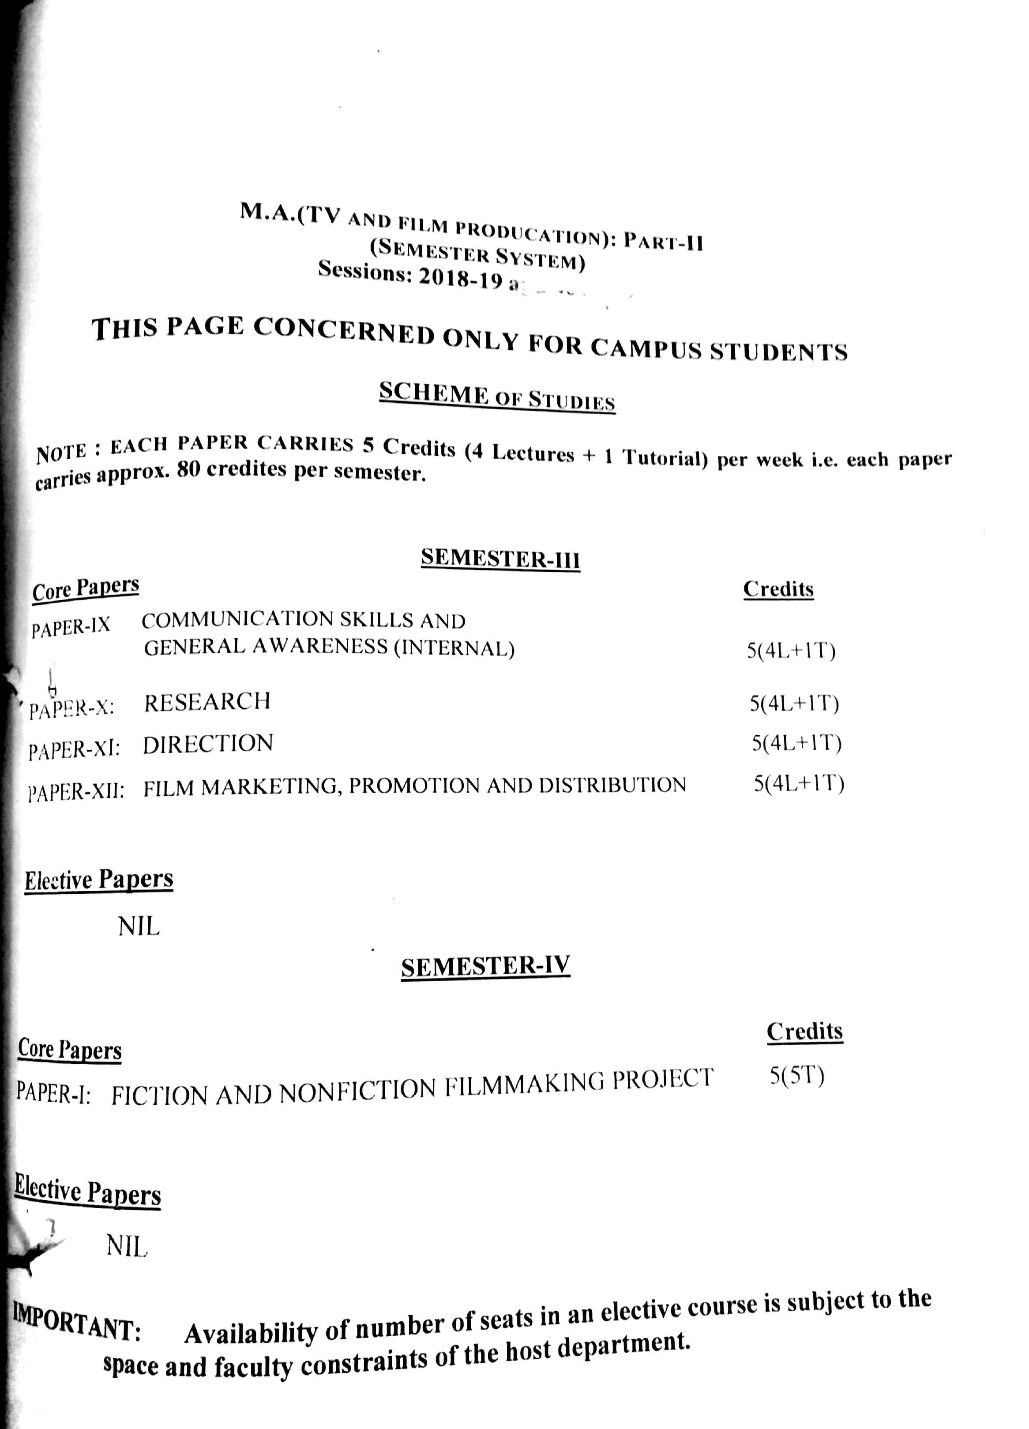

M.A. (TV and film production): Part-II
(Semester System)
Sessions: 2017-18 and 2018-19

outline of tests

SEMESTER-III

PAPER-IX: Communication Skills and General Awareness (INTERNAL)
PAPER-X: Research
PAPER-XI: Direction
PAPER-XII: Film Marketing, Promotion and Distribution

SEMESTER-IV

PAPER-XIII: Project (Fiction or Non-fiction filmmaking)

Semester-III

PAPER-IX: Communication Skills and General Awareness (INTERNAL)

Max. Marks : 100 Continuous Internal Evaluation 80 Marks
Pass Marks : 35 Internal Assessment 20 Marks

Course Content

Section A

All current general issues of national importance: Female Feticide, Global Warming, Depleting Water level and other social issues.Events and Issues of the Year: Sports, Bollywood, Business, Politics, Education and other issues of National, International and Regional.Preparation and presentation of at least two reports of 10 minutes each, based on clipping files from newspapers and magazines, including one related to TV and/or Films.

Section B
Preparing for interviews, Group Discussions, Body language and Gestures, Participation in Debates,Stage management, Self-expression and Self-confidence exercises, Conversations, Quiz.
Writing:Sentence making, Reviews, write short narrative and descriptive paragraphs, slogans, short message and caption.
Composition: Any kind of composition like diary writing, dialogue and story.

Practical: Class Presentations, Assignments on major issues, debates and discussions on current affairs, quiz, file clipping/weekly review, communication and writing skills.

Text and References
- Regional, National, International newspapers & magazines'.

PAPER-X:Research

Max. Marks : 100 Theory: 60 Marks
Pass Marks : 35 Practical: 20 Marks
Time Allowed : 3 Hours Internal Assessment: 20 Marks

INSTRUCTIONS FOR THE PAPER-SETTER
The question paper will consist of three sections: A, B and C. Sections A and B will have four questions from the respective sections of the syllabus and will carry 10 marks each. Section C will consist of 10 short-answer type questions which will cover the entire syllabus uniformly and will carry 20 marks in all.

INSTRUCTIONS FOR THE CANDIDATES
Candidates are required to attempt two question each from the sections A and B of the question paper and the entire section C.
Course Content
SECTION-A

Mass Communication Research (MCR); Meaning and concept, search vs.research; importance and objectives. Research design: Review of literature, statement of the problem; Significance of research, stating objectives & hypotheses,Synopsis writing.
Types of research; Pure, Applied, Fundamental, Qualitative, Quantitative, Empirical, Descriptive, Analytical.Use of communication theories and models in MCR;.Research methodology; Major research methods used in MCR-Survey, Contentanalysis, Historical, Experimental, Observational, Case Study, Longitudinal studies, Questionnaire and its types; Sampling design and its types.Data analyses and processing; Data Coding & tabulation; interpretation; Meaning and concept of Variables, types of variables, Measurement Scales; Measures of Central Tendency; Measures of Dispersion; Correlation & Coefficient of Correlation. Research Report writing; and their fulfillment; Description of findings; Limitations and suggestions; Chapterisation; Bibliography, references.

SECTION-B

Research as important component of filmmaking, importance of Research in film making, research for fiction and non-fiction films, Sources of retrieving research material for various genres of film, the importance of research at various stages of film production – Idea formation, scriptwriting, production design, location,characters, costume, props, life style, Budget.

Text and References
- Introduction to Mass Communication : Gamble and Gamble.
- Communication Theories :Severin, Warner J. and Tankard, James.
- Communication and Culture : Holt, Rinchart and Winston.
- Fundamentals of Communication : Jensen.
- Dictionary of Journalism & Mass Commnication :Maan, Gurmeet.
- The Story of Mass Communication :Mann, Gurmeet Singh.

PAPER-XI:Direction

Max. Marks : 100 Theory: 60 Marks
Pass Marks : 35 Practical: 20 Marks
Time Allowed : 3 Hours Internal Assessment: 20 Marks

INSTRUCTIONS FOR THE PAPER-SETTER
The question paper will consist of three sections: A, B and C. Sections A and B will have four questions from the respective sections of the syllabus and will carry 10 marks each. Section C will consist of 10 short-answer type questions which will cover the entire syllabus uniformly and will carry 20 marks in all.

INSTRUCTIONS FOR THE CANDIDATES
Candidates are required to attempt two question each from the sections A and B of the question paper and the entire section C.

Course Content

Section A
Films as a medium of director, Director as a story teller, director’s role in filmmaking, director and his team, Qualities and responsibilites of a director, Director’s prep for a scene and project, understanding of the story, reading the script and forming the relationship with the script, Breaking down and analysing the script, visualising, analysing, rehearsing and staging the scene.

Section B
Film language and grammar- the film world, film language, shots, film grammar, the 180 degree rule, the 30 degree rule, screen direction, film-time, compression, elaboration, familiar image, the dramatic elements embedded in the script, staging, camera, beats, Master shot and inserts, Camera as replacement of the human eye, Movements – Subject movements, camera movements, combined movements.

Text and References
- Film Directing Fundamentals by Nicholas T. Proferes

Directing: Film Techniques and Aesthetics by Michael Rabinger and Mick Hurbis
- Film directing, shot by shot : visualizing from concept to screen by Steven D. Katz

Recommended Directors and their Films
- Alfred Hitchcock – North by Northweast
- Orson Welles - Citizen Kane
- John Ford- Stagecoach
- Martin Scorsese – Taxi Driver
- Akira Kurosawa – Rashomon, The Seven Samurai
- Ingmar Bergman-The Seventh Seal,Wild Strawberries
- Gulzaer – Mausam, Aandhi, Maachis
- Satyajit Ray – Pathar Panchali
PAPER-XII:Film Marketing, Promotion and Distribution

Max. Marks : 100 Theory: 60 Marks
Pass Marks : 35 Practical: 20 Marks
Time Allowed : 3 Hours Internal Assessment: 20 Marks

INSTRUCTIONS FOR THE PAPER-SETTER
The question paper will consist of three sections: A, B and C. Sections A and B will have four questions from the respective sections of the syllabus and will carry 10 marks each. Section C will consist of 10 short-answer type questions which will cover the entire syllabus uniformly and will carry 20 marks in all.

INSTRUCTIONS FOR THE CANDIDATES
Candidates are required to attempt two question each from the sections A and B of the question paper and the entire section C.

Course Content

SECTION A
Importance of film publicity, an overview of film industry, Market Research, film marketing and promotion, Promotional campaigns, creating movie trailers and teasers, , Tie-ups and merchandising, PR and publicity drives, Press Conference and interactions, latest trends in film promotion

SECTION-B

Distribution systems or models, Single screen vs. multiplex, Major distribution companies in India, publicity through new media Film Distribution economics, Changeover to Digital Distribution and its effects, Multi-Platform release. Corporatization of Mumbai Film Industry, emergence of Multiplexes, overseas markets, Influx of Foreign Players and their strategies, Case study of some major Indian and foreign releases
Text and References
- Making Movies by Sydney Lumet, Vintage (March 19, 1996).
- Fundamentals of Television Production: Donald, Ralph & Spann, Published 2000, Blackwell Publishing
- Film Production Management: Bastian Clevé, Published 2003, Focal Press

Practical: Presentation on innovative marketing and promotion techniques.

Semester- IV

Paper XIII: Project (Fiction or Non-fiction Filmmaking)

Max. Marks 100
Pass Marks: 35

Students will be required to work on a practical project assigned by the teacher(s) during the semester. A viva-voce will be held to evaluate the films made by the students. Evaluation will be based on the following components: a) Production book and script b) Quality of Research c) Quality of Shoot and d) Editing
The minimum duration of the project should be 10 Minutes. The Project should be submitted alongwith a Production Book comprising compilation of Proposal, Research, Budget, Treatment, Script, Screenplay, Storyboards, Breakdown Sheet, Permissions, Production and Contract forms.

